Smart Testing User Guide


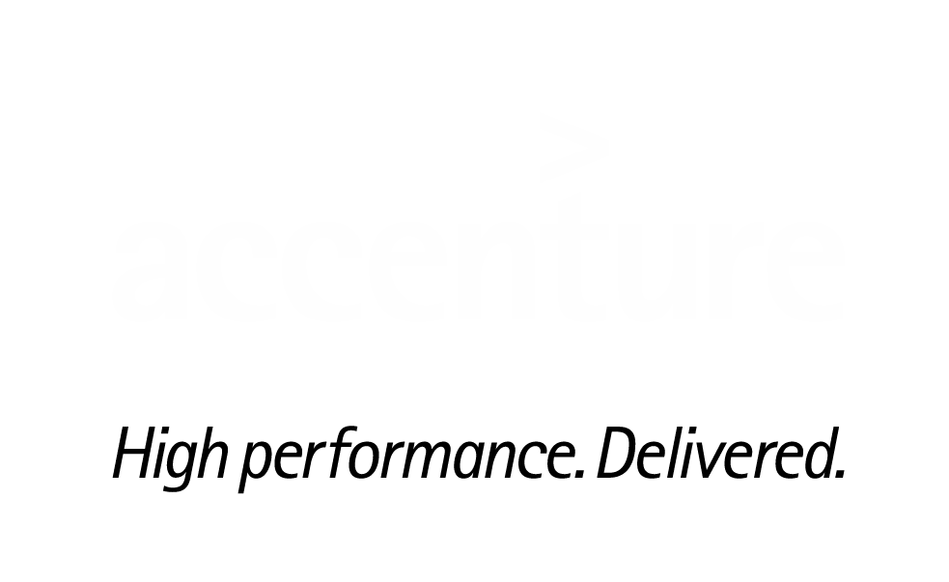

Document Control

Change Record
Date | Author | Version | Change Summary
28/11/16 | Vijaykumar Venkatappa | 1.1 | Initial draft
19/11/16 | Vijay Kumar Albert | 1.1 | Draft

Document Approvers
Name | Organization | Role
Lalitha Yengaldas | Testing Capability | Associative Manager
Chinmaya Ranjan Jena | Testing Capability | Manager
Girish Kulkarni | Testing Capability | Senior Manager

Document Contributors
Name | Organization | Role
Vijaykumar Venkatappa | Testing Capability | Team Lead
Vijay Kumar Albert | Testing Capability | Senior Analyst

Table of Contents

1. Introduction 4
2. Pre-Requisites 4
3. Creating a Workspace and the project 4
4. Development of Test Scripts 4
4.1 Creating the Object Map 4
4.2 Creating the Test Scripts 6
4.3 Creating the Test Data 7
5. Creating the Runner Class 9
6. Creating the Batch Runner for Parallel execution 9
7. How to Execute? 11
8. Reporting 12

Introduction

Continuous Testing is a platform where user can test their end to end application, starting from source code compilation, build, junit and testing. It is a light weight framework user can install this framework easily into their application with minimal support of Asset Team.

Pre-Requisites

As per the system configuration please ensure that the below pre-requisites has been configured in the machine where continuous testing to be installed

- Eclipse
Link: http://www.eclipse.org/downloads/packages/release/Oxygen/M2
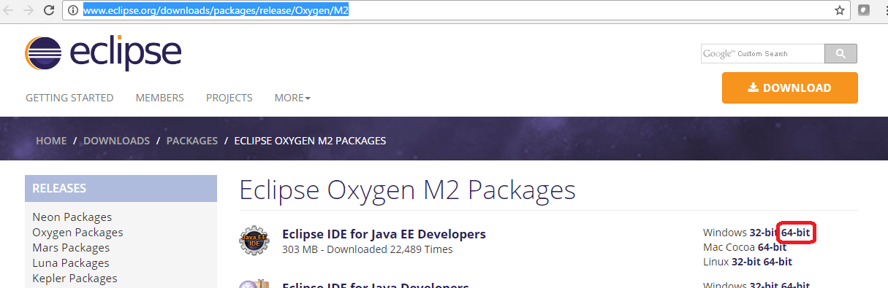

- JAVA 1.8
Link:

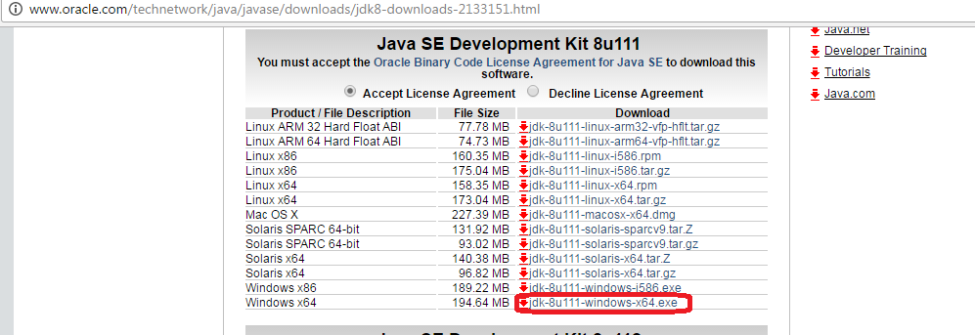

- Jenkins (If required)
- MS Office – Excel

Creating a Workspace and the project

Please follow the below steps in creating a workspace to place the build in order to access it from the workspace

- After double click on eclipse.exe it will prompt to create/open the workspace. Enter the name.
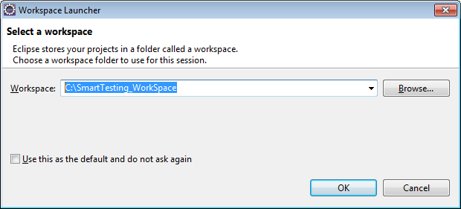

- Place the Smart Testing build into your workspace folder as a project as local folder.
- Open the Eclipse provide the workspace(where you placed the build) in eclipse
- Right click on Project Explorer section → click on import → Import maven project(Smart_Testing) into your workspace as an existing maven project
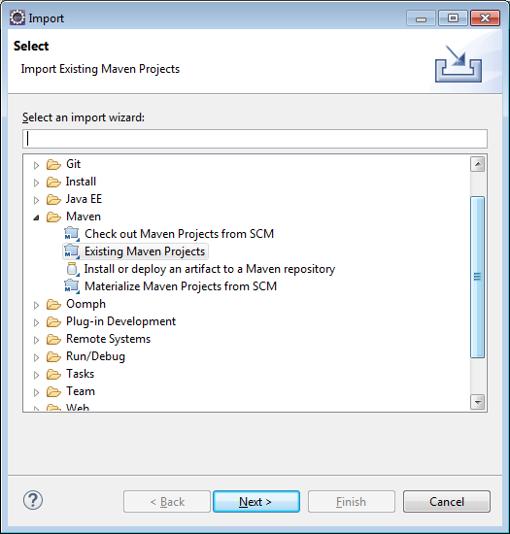
- Open the pom.xml and run as maven install
- Make sure that project do not contain java compilation issue
- If you have any java build path issue please follow the below steps
Right click on Smart_Testing project → click on properties → select libraries under java build path → remove default JRE Library → add installed jdk/jre path to eclipse by selecting Add Library → select JRE system library →browse Installed JRE’s → click on Add → select Standard VM → provide JRE home directory till JDK path
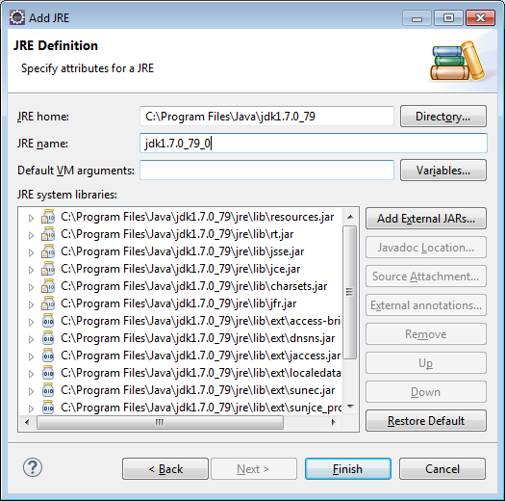

Development of Test Scripts

4.1 Creating the Object Map

Users are supposed to capture the objects from an application and update it in the XLS file and place it in the workspace in the project folder path.

For Example: C:\[YourWorkspace]\Smart_Testing\testscriptrepository\objectmap

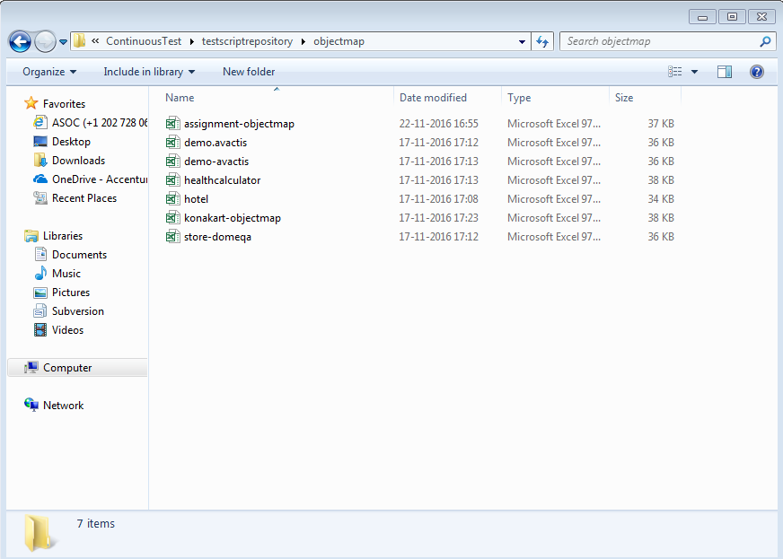

User has to follow the given template to create the object map

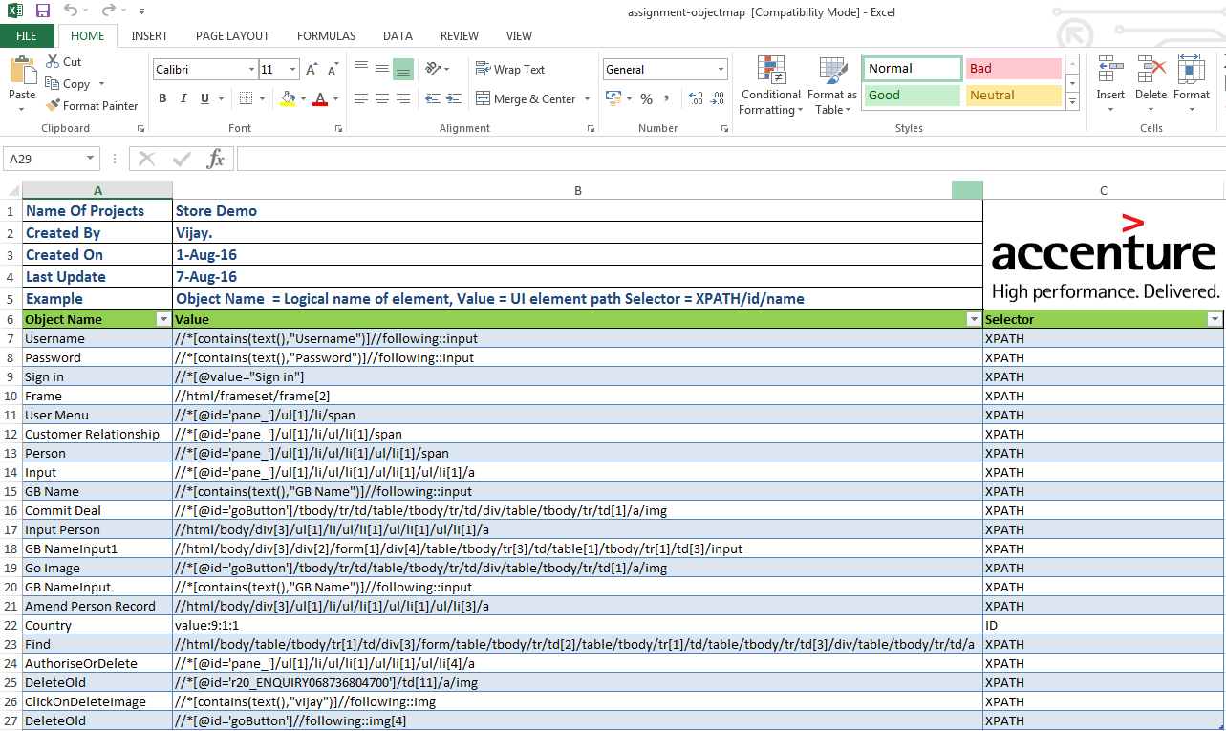

The three columns are supposed to get filled with the captured data. The first column named “Object Name / Logical Name” are user defined. User can define the object name as per his understandable format.

The second columned named “Value” are the actual element identifier captured from the application to be filled out.

The third column named “Selector” to be filled with the selectors that element identifier belongs to. For Example: - ID, Name, XPATH, iframe etc.

4.2 Creating the Test Scripts

Once the object map has been created, user has to create the Test Script file where the actual test steps are supposed to get documented in the XLS file with the given template and also to be placed in the project folder path

For Example: C:\[YourWorkspace]\Smart_Testing\testscriptrepository\testscripts

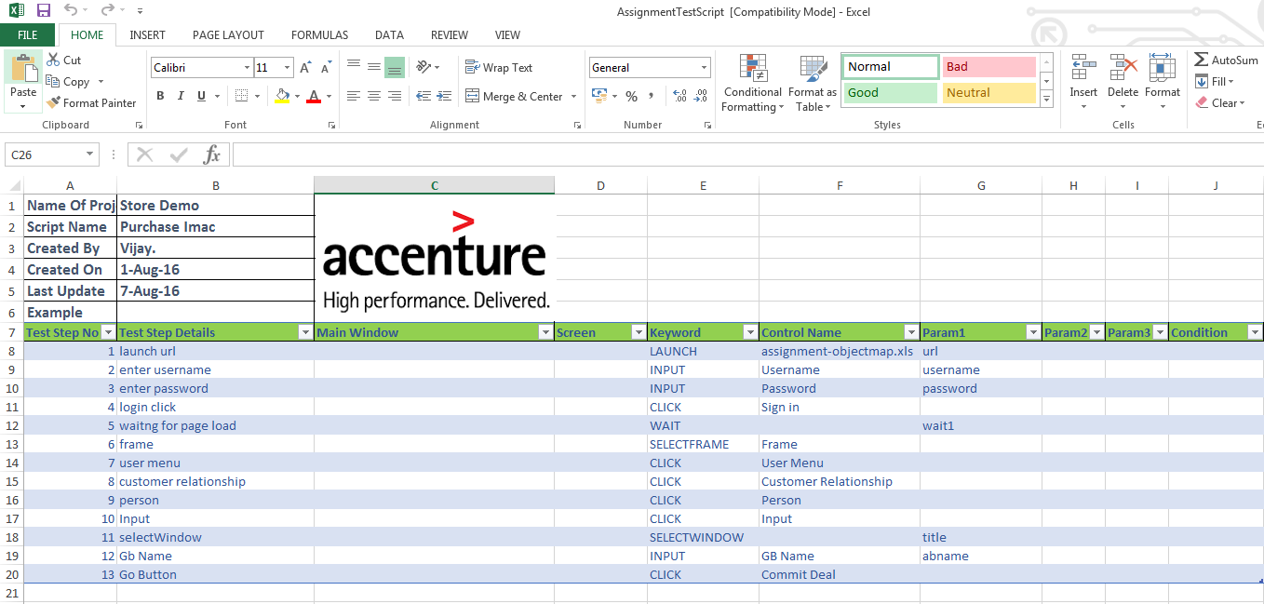

The template contains the columns like Test Step No, Test Step Details, Main Window, Screen, Keyword, Control Name, Param1, Param2, Conditions etc.,

- The Test step no. will be inputted with the Test step number that should be in the sequence.
- The Test Step Details is user defined, user can define the steps with the preferred content that defines the step

For Example: User can provide the content as “Click on the Login button” for the step that are supposed to click the Login button.

- The Keyword column are supposed to fill out with the keyword name that performs the action.

For Example: Launch, Input, SelectfromList etc.

- The Control Name column to be fill out with the Object name that has been passed in the object map file.

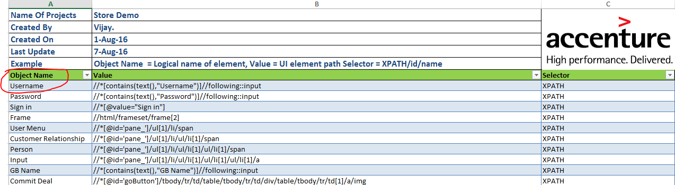

4.3 Creating the Test Data

Once the Test Scripts has been created, user has to create the Test Data file where the actual test data are supposed to get documented in the XLS file with the given template and also to be placed in the project folder path

For Example: C:\[YourWorkspace]\Smart_Testing\testscriptrepository\testdata

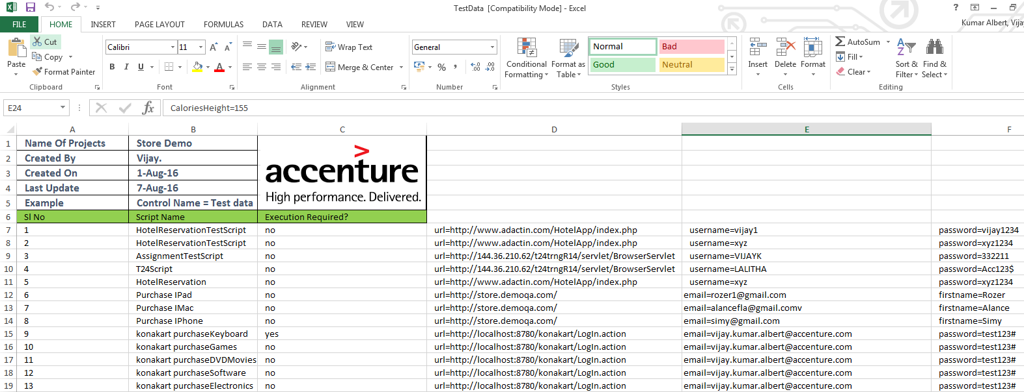

- The S.No. Column to be filled with the numbers in the sequential order that will leads to an execution of the given scripts in the sequential order.
- The Script Name column to be fill out with the Test Script file name

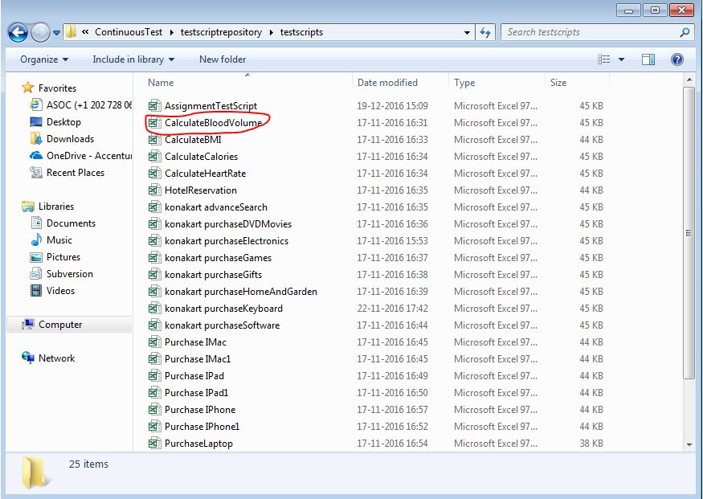

- The Execution Required? Column to be filled with either Yes/No to ensure the corresponding Test Scripts are supposed to get executed or skipped.
- The Next immediate columns to be fill out with the parameter name that has been passed for the steps in the Test Script file

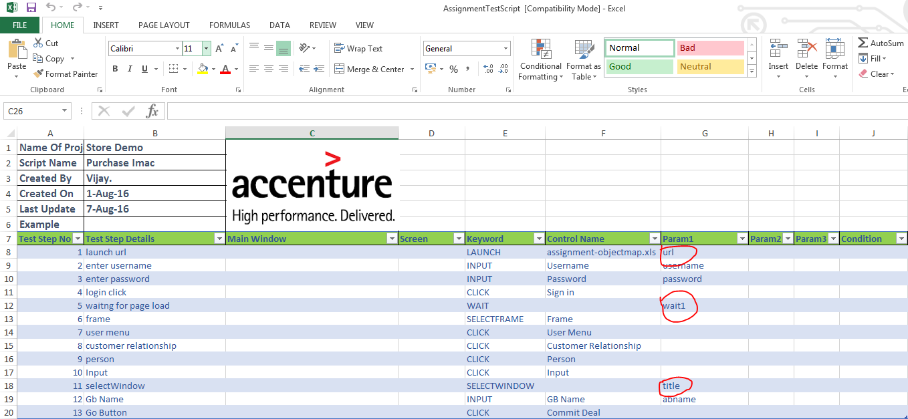

- To iterate the same Test script user has to pass the respective Test Script name in n number of rows with different test data.

Creating the Runner Class

Once the Test Script and Test Data file has been created, user has to create the runner class for the given test script in the package

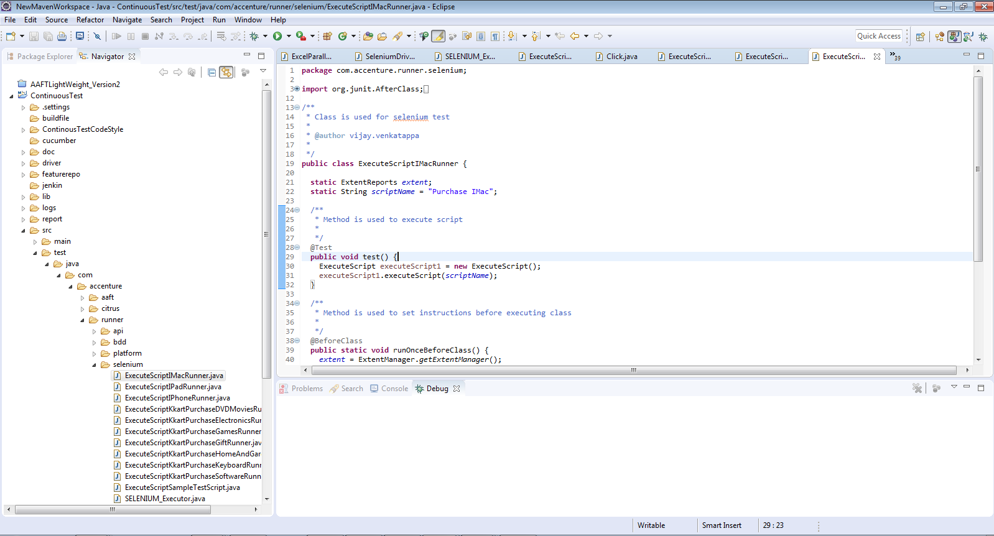

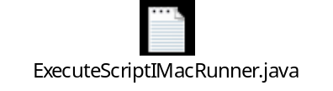

Creating the Batch Runner for Parallel execution

Once the runner class has been created for the test scripts, user has to fill out the Runner Repository file by creating a sub folder in the folder path

C:\[YourWorkspace]\Smart_Testing\RunnerRepository

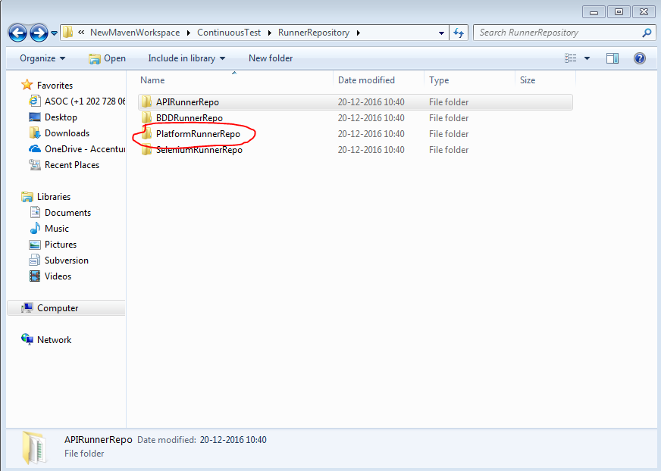

User has to create the repo in the given template and should be placed in the created sub folder
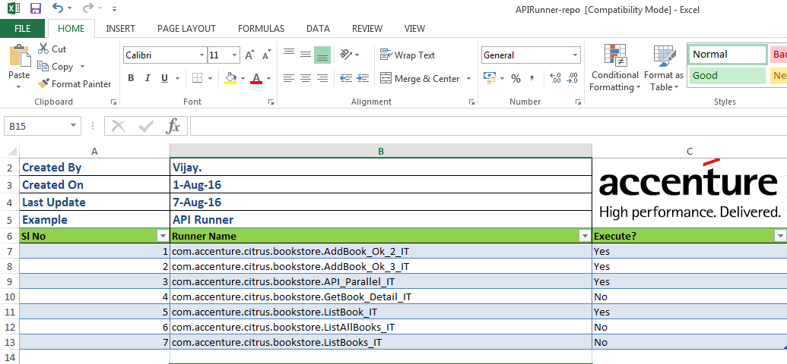

- The S.No. Column to be filled with the numbers in the sequential order that will leads to an execution of the given scripts in the sequential order.
- The second column to be filled with the Runner Name i.e. the name of the runner class.
- The Execution Required? Column to be filled with either Yes/No to ensure the corresponding Runner class that invokes the Test Scripts are supposed to get executed or skipped.

How to Execute?

Once the Runner Class and Runner Repo has been created, user has to open the Eclipse and navigate to the project for Smart Test and press the Ctrl+Shift+R from the keyboard to navigate to the SELENIUM_Executor class

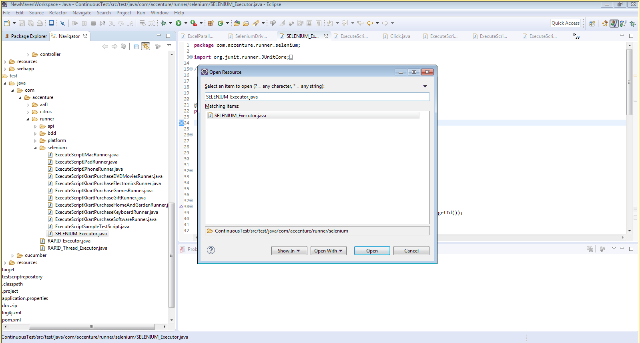

- Open the SELENIUM_Executor class.
- Right click on the editor and navigate to Run As -> JAVA Application.
- Or user can open runner class and navigate to Run As -> JUnit Application.

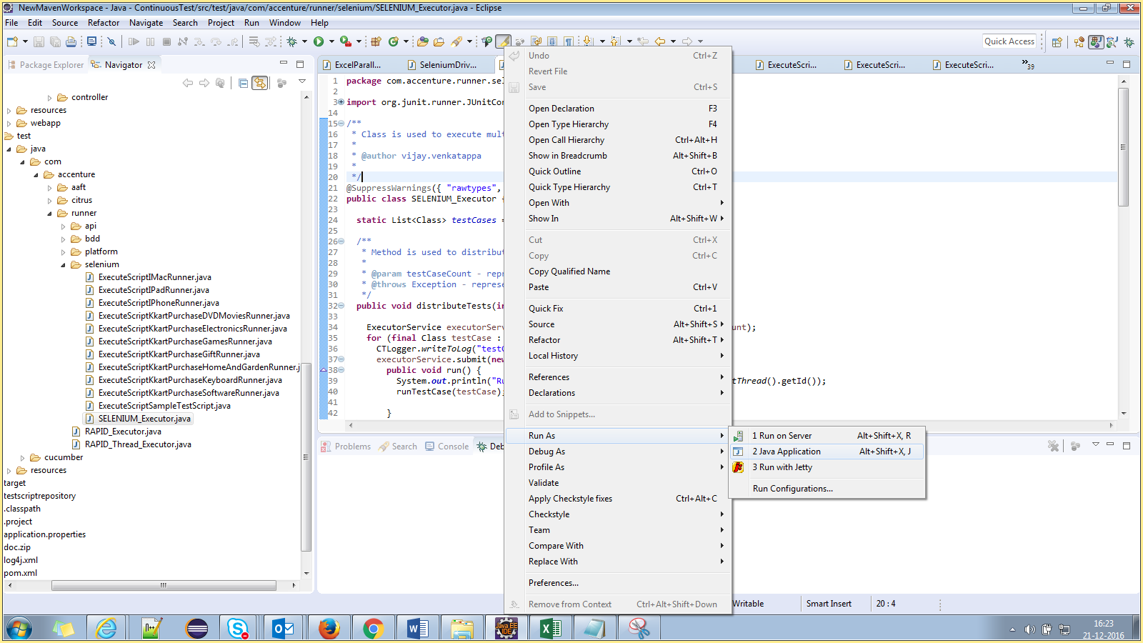

- The execution will get started by launching the browser.

Reporting

Once the execution got completed, reports will get generated in the folder path

C:\[YourWorkspace]\Smart_Testing\report

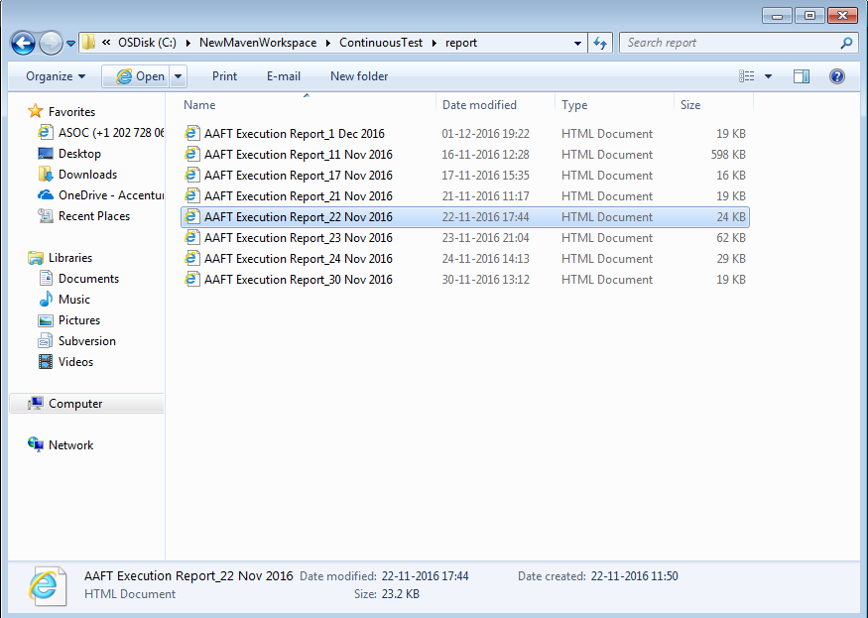
By opening the individual report, will launch it in the form of HTML

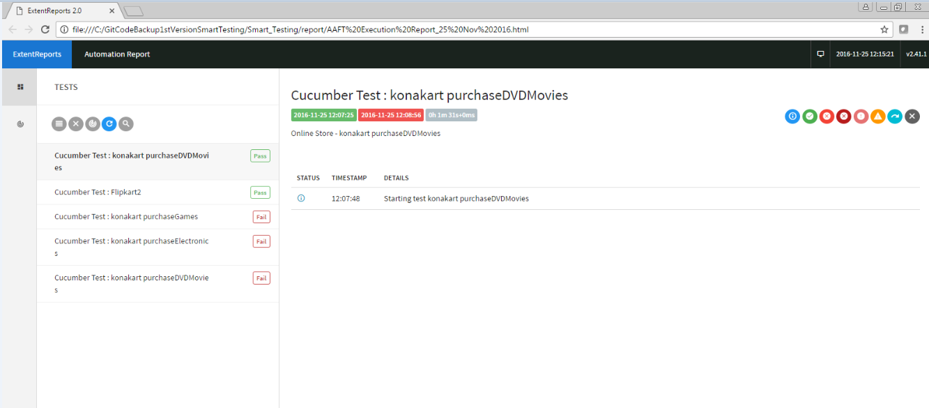

By clicking on the pie chart icon, user will get the graphical representation of an execution report

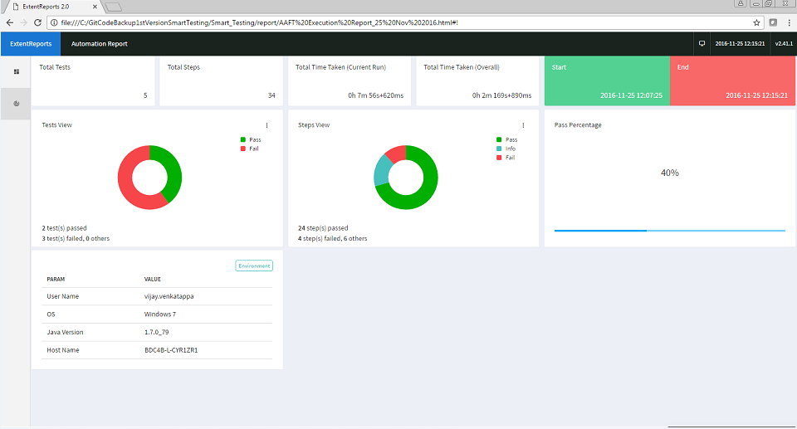

Please click on the below link to know more about Extent Report
http://extentreports.relevantcodes.com/
http://extentreports.relevantcodes.com/java/
Folder Structure:
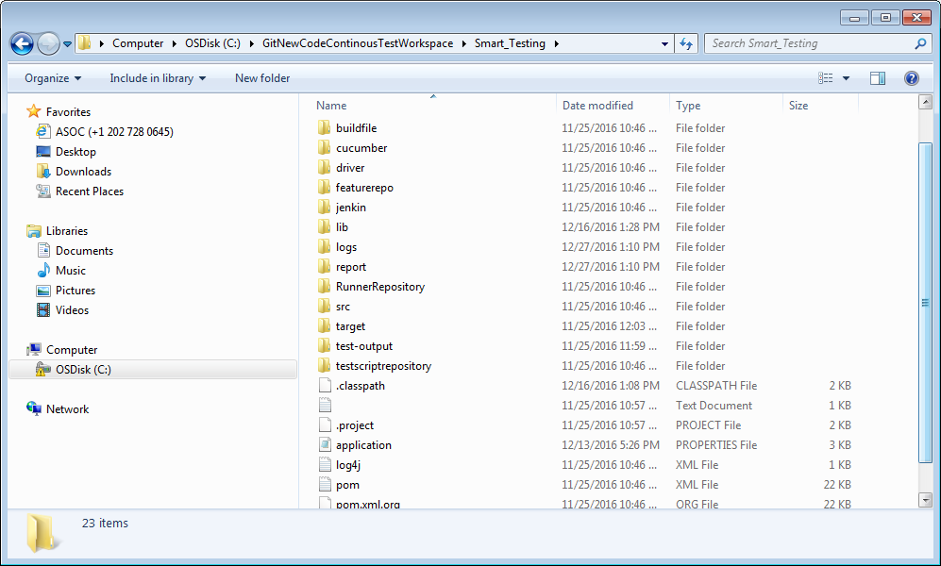

Important Folder Details:
- Src folder contains Smart_Testing project source code
- Driver folder contains browser driver esecutables
- Logs folder contains logger files
- Report folder contains eecution result in html format
- Runner Repository folder contains excel files where it holds runner classes details with package
- Target folder contains execution required files
- TestcriptRepository folder contains objectmap, script and test data excel files.

